

**ANL488 Report Summary (American Express)**

The below summarises American Express employee information. The information obtained comes from Glassdoor.  
  
Do note that the report is designed to help the company summarise employee description, and is for general information purposes only. All analyses on the site is provided in good faith and it make no representation of any kind, express or implied, regarding the accuracy, or completeness of the company.

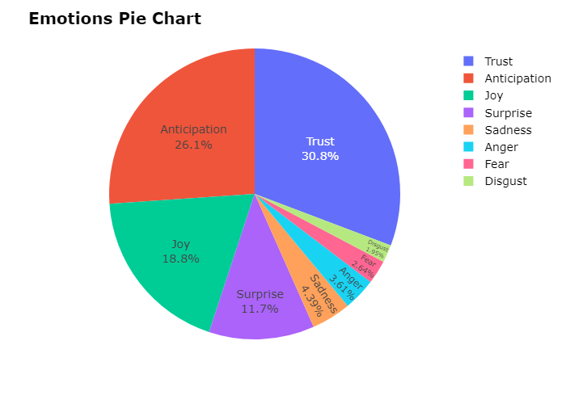

The emotion chart illustrates the proportions of specific emotions (Anticipation, Trust, Joy, Surprise, Sadness, Fear, Anger and Disgust).  
  
The calculation of emotion is based upon the NRC Emotion Lexicon, that contains a list of words and their associations with eight basic emotions. Each word in the employee review will be mapped against the NRC emotion lexicon to compute the overall emotion expressed by the employee.  
  
Based on the chart above, Trust (30.76%), Anticipation (26.07%), and Joy (18.85%) are amongst the top 3 emotions expressed.

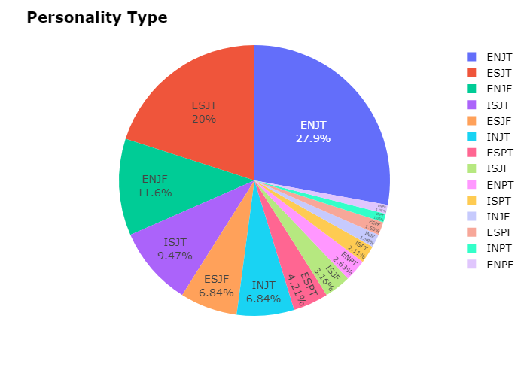

The personality chart illustrates the proportions of 16 Myers-Briggs Personality Type (MBTI) Types. MBTI is a self-report inventory designed to identify a person's type, strengths, and preferences. Through a person's MBTI, we are able to determine his strengths, weaknesses, possible career preferences as well as their compatiblity with other people.  
  
The calculation of personality is based upon the personality cafe, which is a forum that is dedicated to all ranges of personality types. The following derives a person's personality by applying text classification task using natural language processing and deep learning.  
  
Based on the chart above, ENJT (27.89%), ESJT (20.0%), and ENJF (11.58%) are amongst the top 3 personality type of American Express Employees.  
  
ENJT are known as nan, where they are nan  
  
ESJT are known as nan, where they are nan  
  
ENJF are known as nan, where they are nan

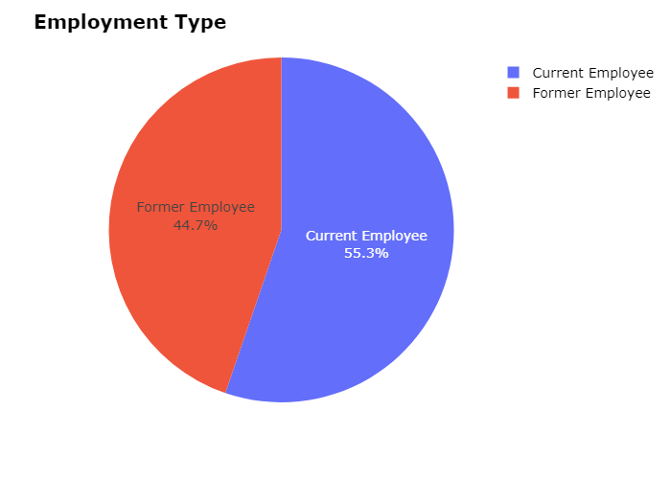

The employment chart illustrates the employment type of reviewers for American Express on Glassdoor.  
   
The breakdown shows that the majority of reviewers are Current Employee (55.26%) and Former Employee (44.74%).

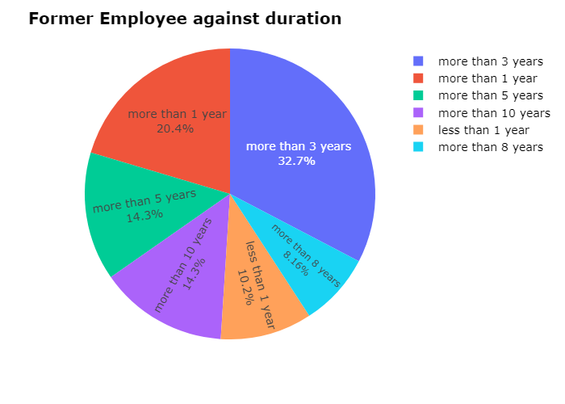

A closer look at the duration of former employee gives us an overview of how often does an employee usually stays in the company.  
   
It can be seen that the majority of employee stays for more than 3 years (32.65%) and more than 1 year (20.41%).

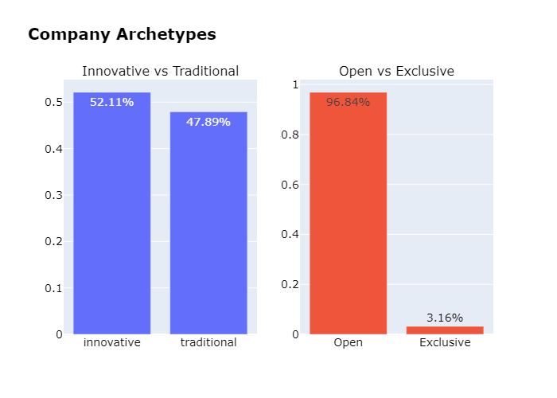

The company archetype shows 3 archetypes of a company Innovative-Traditional, Open-Exclusive, and Extrovert-Introvert.   
   
Innovative and Traditional is derived by scraping the posts of innovative and traditional companies on LinkedIn, and using natural language processing (NLP) and Naive Bayes Classifier to classify reviewer's comments about the company.  
   
Open and Exclusive is derived from the emotion, where a study suggests that a person whose review suggest anger, fear and disgust evaluates the company as exclusive and a person that shows joy, trust and anticipation on the company as exclusive.  
   
Introvert and Extrovert defines the company personality, where the model is trained using posts by people of different personality from the personality cafe forum.  
   
It can be seen that reviewers deemed American Express as innovative (52.11%), Open (96.84%) and Extrovert (75.79%)

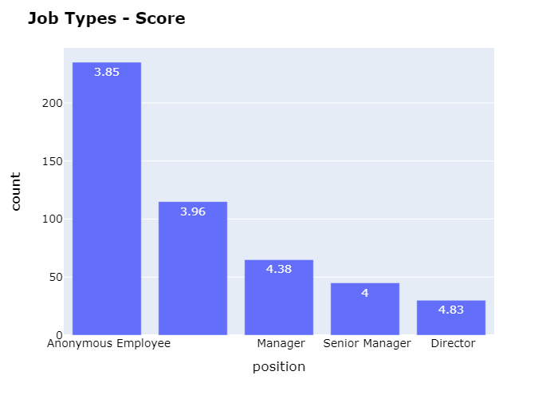

The job type chart gives us an overview of the top 5 roles that provide reviews for American Express.   
   
It also tells us the average score a person give on Glassdoor based on these positions. It can be seen that Anonymous Employee (235) gives an average score of 3.85, (115) an average of 3.96, Manager (65) an average of 4.38, Senior Manager (45) an average of 4.0, and Director (30) an average of 4.83

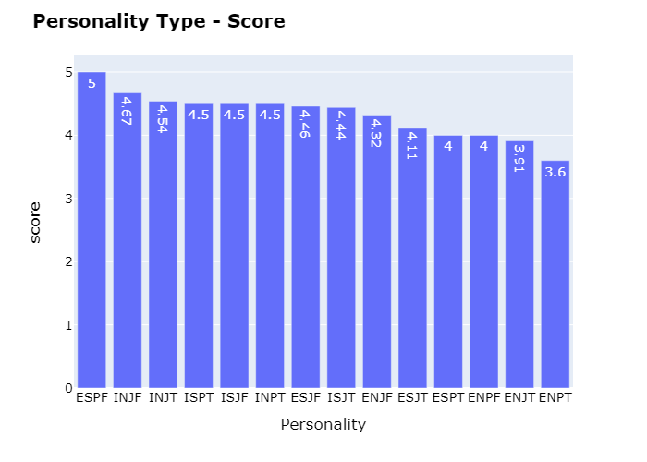

The personality tytpe breakdown shows us the average score given by the different personality on the company. This allow us to have a better sense as to which personality type would be more satisfied working at American Express as compared to the others.   
   
ESPF, INJF and INJT are the top 3 personality types that gives an average score of 5.0, 4.67 and 4.54 respectively  
  
ESPT, ENJT and ENPT are the bottom 3 personality types that gives an average score of 4.0, 3.91 and 3.6 respectively. This will indicate that employees of these personalities will require a strong leader to improve the low employee engagement.

Singapore University of Social Sciences  
 463 Clementi Rd, Singapore 599494  
 Email: zyng005@suss.edu.sg, Phone: +65 9837 3952